**EVALUATION OF PROJECT**

Jeremy Hadfield

Advanced Web Development Winterim

January 20, 2016

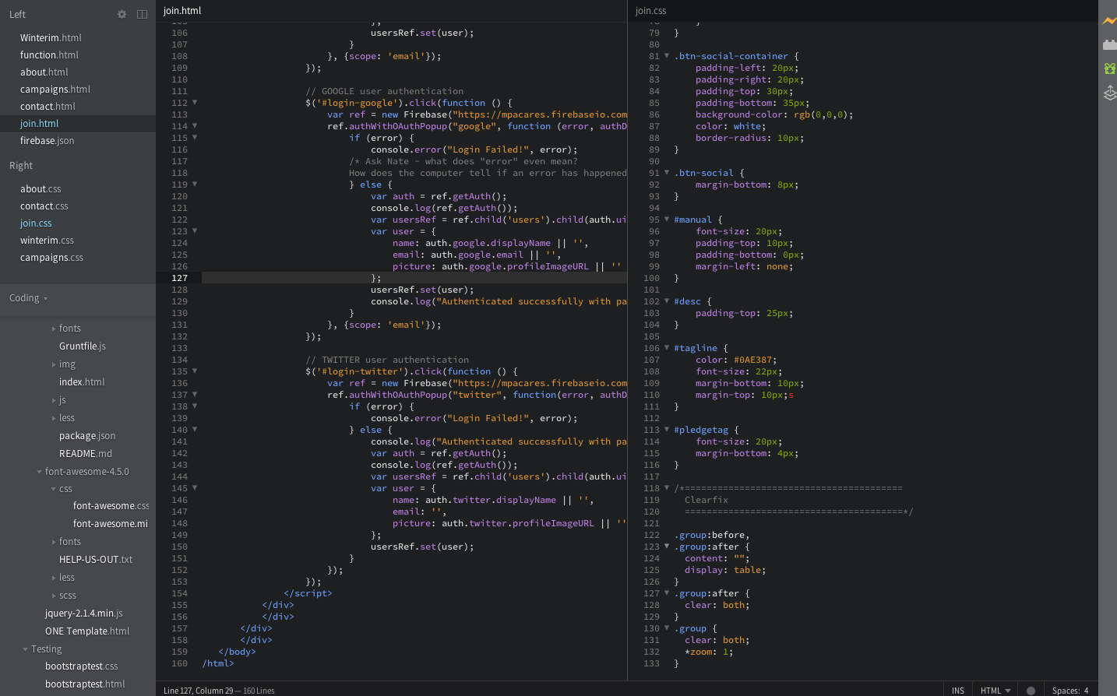**OVERVIEW:** This Winterim has taught me to implement my ideas with some of the most powerful, yet still simple, software technology in existence. My Winterim project is the product of countless dead ends and a lot of time spent staring at a code-covered screen with no idea where to go next. Especially in this last week, however, I’ve really seen it come together. Throughout the course of building the site, I’ve not only learned the frameworks behind web development – I’ve also learned what this industry is like in practice, and I’ve adopted the thought processes that allow me to create code, debug it, and find solutions to problems.

Above - A sample of the code - this page is the function that allows users to join the site with their social network accounts.

**Successes**

In total, my project consists of 6,247 lines of code in 4 languages – CSS, HTML, Javascript, and JSON – and implemented with 9 frameworks -- Bootstrap, Flat UI, jQuery, jQuery UI, Firebase, Node.js, Backbone.js, Angular.js, and Wordpress. That doesn’t mean that I’m fully proficient in all those languages/frameworks, as I used some of them very little. However, I ended up fulfilling all the technical goals I set at the beginning in my Independent Winterim Proposal.

While I reached the goals I set out to achieve, I ended up working towards them in very different ways than I expected. For example, my goal to finish the jQuery, Javascript, and HTML/CSS paths on Codecademy was mostly completed, but I skipped several sections of these courses because I had either already learned them or they were completely unnecessary. Instead, I learned directly from my mentors or by working through the problems I had and reading the language documentation when I couldn’t figure it out. Basically, while what I was trying to learn did not change, the way I learned it changed dramatically. One of the most valuable things I gained from this Winterim is the ability to find the most efficient resources to learn web development online.

Ultimately, what matters is that I achieved my two most important goals: First, to create a responsive website with at least one back-end function, and second, to understand the software industry and decide whether I want to become a part of it. My website uses Bootstrap, so it is responsive to the user’s screen size and can function as a mobile or desktop site. It also has plenty of animations, connections, and interactions to make the user feel like the site is a dynamic network, not a static page. On the second goal, I’ve actually been startled by my own misconceptions of how the software industry works. For example, while I thought developers worked mostly on their own, I actually spent the majority of my time with my mentors in their team meetings. Both of my mentor’s companies are very social and spend a lot of time working together. Partly because of this positive work environment, as well as the inherent exhilaration in implementing my ideas, I’ve come to really love web development. Right now, my plan is to major in computer science and become a web developer.

**Problems**

Despite the upbeat vibe and the exhilaration of web development, there are a ton of roadblocks I had to surmount in building the site. One of my largest problem in the first couple weeks is that I was painstakingly coding everything by hand, one element at a time. Instead of making broad, sweeping changes with existing frameworks, plugins, and libraries, I was trying to code everything myself. This only resulted in making my site into a messy, overly complex quagmire I had to miserably wade through whenever I wanted to change data. In the second week, I basically overthrew everything I did in the first week and stripped my site to the bare skeleton. Then, I rebuilt it with Bootstrap, which allowed me to make much more progress in minimal amounts of time.

Finally, I was starting to gain traction – but then I hit another massive barrier. I had basically finished most the intermediate web development I needed, and now I was getting into the really advanced material – specifically, Firebase databases and using Node.js, Backbone.js, and Angular.js. This made it much harder to just learn online. After floundering for a brief period while I searched for resources that could effectively teach me how to use these frameworks, I turned to my mentors. I asked them where the best resources where, and they immediately pointed me to several applications and sites that made even this advanced coding (or at least relatively advanced) seem simple.

**Conclusion:**

This Winterim has been perhaps the most valuable thing I’ve done all year. I’ve learned how a software company works, and I’ve set myself on the path to being a participant in one these companies. I’ve learned how to use several of the most crucial tools in the world of modern web development, and now I have the abilities needed to construct a functional site from scratch. I’ve learned to genuinely enjoy programming, which ensures that I’ll continue learning it and advancing my skillset. But most importantly, I’ve learned how to learn software, which will allow me to progress far more rapidly in the future.